**Front end setup instructions**

[**https://ornate-dolphin-8a27b3.netlify.app/**](https://ornate-dolphin-8a27b3.netlify.app/) **- Frontend has been deployed here. No need to setup to run.**

* Download node js - <https://nodejs.org/dist/v18.12.1/node-v18.12.1-x64.msi>

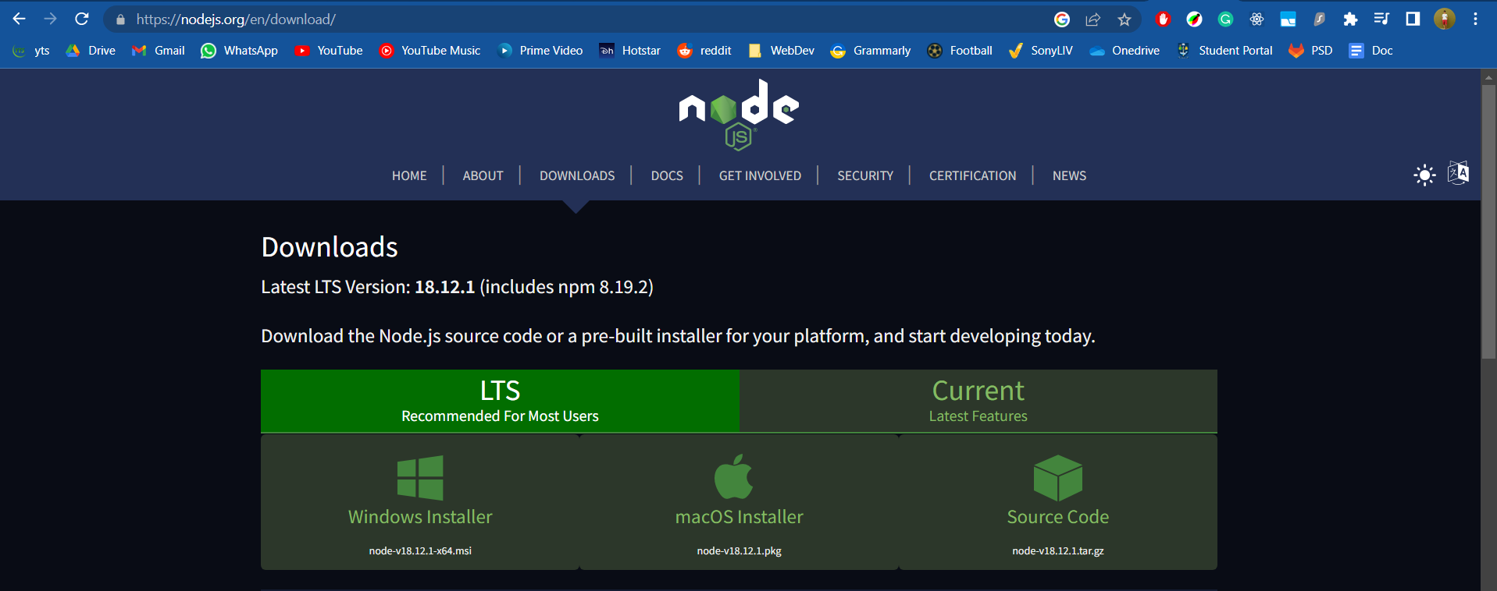

If installing through git -

* Run command – git clone <https://stgit.dcs.gla.ac.uk/programming-and-systems-development-m/2022/lc02-lb03-d/transport-app-react.git>
* Clone repository
* Move into project directory
* Run command – npm install
* Text

  Description automatically generated with medium confidence
* This will install the node_modules folder
* Run command – npm run start-dev to run project on localhost:3000

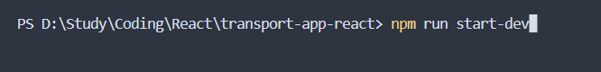

If using the zipped folder –

* Unzip and move into project directory
* Run command – npm install
* Text

  Description automatically generated with medium confidence
* This will install the node_modules folder
* Run command – npm run start-dev to run project on localhost:3000

